 | EBRD press release  EBRD engages with Georgia to improve nursing & midwifery skills  Bank in partnership with the Ministry of Health, Labour and Social Affairs creates opportunities for skilled labour in healthcare. |  |  | 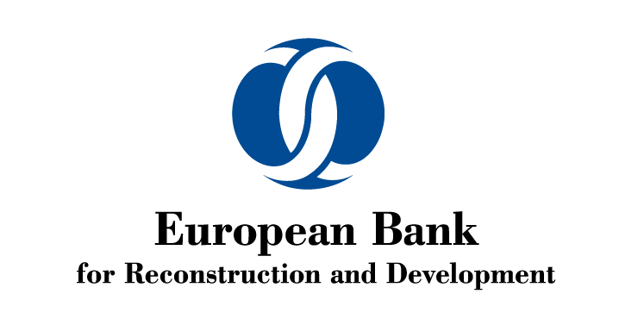
FOR IMMEDIATE RELEASE
 |  | www.ebrd.com/news | 
Date: 15/05/2020  Contact: Loretta Martikian  Tel: +995577221120  Email: martikianl@ebrd.com  Twitter: @LoraMartikian |  |  | Tags: #EBRD #Georgia, #healthcare, #nurses, #nursing, #inclusion

- EBRD is engaged on improving nursing and midwifery skills in Georgia.
- MoU with Government of Georgia signed on International Nurses Day (12 May) on skills development.
- Funding is part of EBRD’s policy engagement initiative through Technical Assistance
The Ministry of Internally Displaced Persons from the Occupied Territories, Labour, Health and Social Affairs of Georgia and the European Bank for Reconstruction and Development (EBRD) are launching a new initiative this week to improve nursing and midwifery occupations through professional licencing, related skills standards and implementation support. The two organisations signed a Memorandum of Understanding (MoU) on Tuesday 12 May in celebration of International Nurses Day for a joint collaboration over the coming two years.
The partners agreed to co-operate more closely in realising three core objectivesb:
  - Establishing core governance principles and institutional standards for Georgia’s forthcoming professional licencing / certification scheme for nurses (including midwives), building on global best practice models and customising to the national context;
  - Establishing detailed knowledge criteria, exam standards and a test-bank aligned to the new professional licencing / certification scheme; and
  - Designing and piloting a short-term continuous learning programme to help further strengthen nurses’ capacities and existing knowledge in accordance with the new licencing / certification requirements.
The new initiative is closely aligned with the Government’s key healthcare priorities outlined under the Parliament of Georgia’s Vision for Developing the Healthcare System (2017) and the Ministry’s Strategy for the Development of Nursing (2019). It also comes at a critical time in strengthening healthcare standards to fortify Georgia’s broader response under the ongoing Covid-19 pandemic crisis.
The new initiative is also closely aligned with EBRD’s goals around economic inclusion in Georgia. Over the past two years, EBRD has helped deliver key achievements in promoting more effective and sustainable nursing in Georgia. The Bank is engaged with local partners in upgrading skills standards for degree-level nursing and midwifery programmes; developing Georgian-language nursing textbooks; and helping to improve outreach to male nurses to help further expand the potential labour pool.
The initiative is especially timely in 2020, which the World Health Organization has designated the international Year of the Nurse and the Midwife, adding additional momentum.
Financing for the new programme comes from the Government of Japan through the Japan-EBRD Cooperation Fund (JECF) promoting economic inclusion through technical assistance.
EBRD is a leading institutional investor in Georgia. Since the start of its operations in the country, the Bank has invested over €3.8 billion in 250 projects in the financial, corporate, infrastructure and energy sectors, with 87 per cent of these investments in the private sector.

